# PROJECT DOCUMENTATION

**Deep Learning Fundus Image Analysis for Early Detection of Diabetic Retinopathy**

##### Team Id: PNT2022TMID02274

**Submitted By:**

**Sharveshwaran R - 2116190701200 - Team Lead**

**Shwetha M - 2116190701204**

**Sanjeev Krishnan R - 211619070186**

**Sneha K S - 2116190701206**

### Table of Contents

1. **INTRODUCTION**
   1. Project Overview
   2. Purpose
2. **LITERATURE SURVEY**
   1. Existing problem
   2. References
   3. Problem Statement Definition
3. **IDEATION & PROPOSED SOLUTION**
   1. Empathy Map Canvas
   2. Ideation & Brainstorming
   3. Proposed Solution
   4. Problem Solution fit
4. **REQUIREMENT ANALYSIS**
   1. Functional requirement
   2. Non-Functional requirements
5. **PROJECT DESIGN**
   1. Data Flow Diagrams
   2. Solution & Technical Architecture
   3. User Stories
6. **PROJECT PLANNING & SCHEDULING**
   1. Sprint Planning & Estimation
   2. Sprint Delivery Schedule
   3. Reports from JIRA

##### CODING & SOLUTIONING (Explain the features added in the project along with code)

* 1. Feature 1
  2. Feature 2
  3. Database Schema (if Applicable)

1. **TESTING**
   1. Test Cases
   2. User Acceptance Testing
2. **RESULTS**
   1. Performance Metrics
3. **ADVANTAGES & DISADVANTAGES**
4. **CONCLUSION**
5. **FUTURE SCOPE**
6. **APPENDIX**

Source Code

GitHub & Project Demo Link

1. **INTRODUCTION**

The main causing of visual loss in the world is diabetic retinopathy. In the initial stages of this disease, the retinal microvasculature is affected by several abnormalities in the eye fundus such as the microaneurysms and/or dot hemorrhages, vascular hyper permeability signs, exudates, and capillary closures. Micro-aneurysm dynamics primarily increase the risk that the laser photo coagulation requires progression to the level. Diabetic retinopathy lesions are commonly accepted to be reversed and the progression of the retinopathy can only be slower during the early stages of the disease. The identification by repeated examination of patients affected of these initial lesions (mainly Micro aneurysms and small blood cells) is expected as a new possibility of improving retinopathy treatment. Floating and flashes, blurred vision, and loss of sudden vision can be common symptoms of diabetic retinopathy.

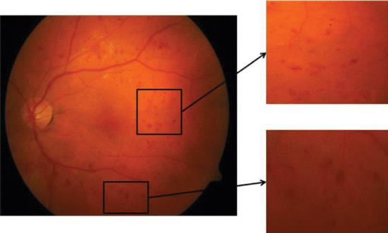

## Project Overview

Diabetic Retinopathy (DR) is a common complication of diabetes mellitus, which causes lesions on the retina that affect vision. If it is not detected early, it can lead to blindness. Unfortunately, DR is not a reversible process, and treatment only sustains vision. DR early detection and treatment can significantly reduce the risk of vision loss. The manual diagnosis process of DR retina fundus images by ophthalmologists is time, effort and cost-consuming and prone to misdiagnosis unlike computer-aided diagnosis systems.

Transfer learning has become one of the most common techniques that has achieved better performance in many areas, especially in medical image analysis and classification. We used Transfer Learning techniques like Inception V3, Resnet50, Xception V3 that are more widely used as a transfer learning method in medical image analysis and they are highly effective.

## Purpose

The Proposed work intends to automate the detection and classification of diabetic

retinopathy from retinal fundus image which is very important in ophthalmology. Most of the

existing methods use handcrafted features and those are fed to the classifier for detection and

classification purpose. Recently convolutional neural network (CNN) is used for this classification

problem but the architecture of CNN is manually designed. In this work, a genetic algorithm based

technique is proposed to automatically determine the parameters of CNN and then the network is

used for classification of diabetic retinopathy. The proposed CNN model consists of a series of

convolution and pooling layer used for feature extraction. Finally support vector machine (SVM)

is used for classification. Hyper-parameters like number of convolution and pooling layer, number

of kernel and kernel size of convolution layer are determined by using the genetic algorithm. The

proposed methodology is tested on publicly available Messidor dataset. The proposed method has

achieved accuracy of 0.9867 and AUC of 0.9933. Experimental result shows that proposed auto-

tuned CNN performs significantly better than the existing methods. Use of CNN takes away the

burden of designing the image features and on the other hand genetic algorithm based methodology

automates the design of CNN hyper-parameters.

1. **LITERATURE SURVEY**

**2.1. EXISITING PROBLEM**

Diabetic Retinopathy (DR) is a degenerative disease that impacts the eyes and is a consequence of Diabetes mellitus, where high blood glucose levels induce lesions on the eye retina. Diabetic Retinopathy is regarded as the leading cause of blindness for diabetic patients, especially the working-age population in developing nations. Treatment involves sustaining the patient’s current grade of vision since the disease is irreversible. Early detection of Diabetic Retinopathy is crucial in order to sustain the patient’s vision effectively. The main issue involved with DR detection is that the manual diagnosis process is very time, money, and effort consuming and involves an ophthalmologist’s examination of eye retinal fundus images. The latter also proves to be more difficult, particularly in the early stages of the disease when disease features are less prominent in the images. Machine learning-based medical image analysis has proven competency in assessing retinal fundus images, and the utilization of deep learning algorithms has aided the early diagnosis of Diabetic Retinopathy (DR). This paper reviews and analyzes state-of-the-art deep learning methods in supervised, self-supervised, and Vision Transformer setups, proposing retinal fundus image classification and detection. For instance, referable, non referable, and proliferative classifications of Diabetic Retinopathy are reviewed and summarized. Moreover, the paper discusses the available retinal fundus datasets for Diabetic Retinopathy that are used for tasks such as detection, classification, and segmentation. The paper also assesses research gaps in the area of DR detection/classification and addresses various challenges that need further study and investigation.

**2.2. REFERENCES**

Fulong Ren 1 2 , Peng Cao 1 2 , Dazhe Zhao 1 2 , Chao Wan 3 macula localization, exudate candidate identification with vector quantization and exudate candidate classification with semisupervised learning. The proposed method and the state-of-the-art approaches are compared in terms of performance, and experimental results show the proposed system overcomes the challenge of the DME grading and demonstrate a promising effectiveness. Kangrok Oh, Hae Min Kang, Dawoon Leem, Hyungyu Lee, Kyoung Yul Seo & Sangchul Yoon.They measure image-wise RSD values using the test model outputs from the ten runs of cross-validation tests. Consequently, average RSD values for both DR detection systems based on ETDRS 7SF and F1–F2 images are reported Silva et al. demonstrated that peripheral lesions identified on UWF imaging are associated with the increased risk of DR progression37. Those pioneering studies33,34,35,36,37 regarding the UWF imaging for DR severity evaluation utilized capturing devices from Optos. The wide-field scanning laser ophthalmoscopy (SLO) by Optos provides a single image covering nearly 200∘ of the retina18. During transforming the wide-field image of the spherical eye into the 2-D image, small lesions may be inconspicuous due to distortion18. Furthermore, eyelashes and eyelids cover the superior and inferior periphery of the retina in some cases32. Aiello et al.33 demonstrated that the ETDRS 7SF photography and corresponding fields in the UWF photography have moderate to substantial agreements for DR severity evaluation. Poornima S V, Parvatha Lakshmi B, Nishchala T K, Umamakeswari A automated the detection of diabetic retinopathy, thereby eliminating errors culminated by human measurement. Fundus images obtained from HRF database [2] have been used for this study. Early Detection of Diabetic Retinopathy by Using Deep Learning Neural Network Mohamad Hazim Johari1, Hasliza Abu Hassan2, Ahmad Ihsan Mohd Yassin1*, Nooritawati Md Tahir1, Azlee Zabidi1, Zairi Ismael Rizman3, Rahimi Baharom1, Norfishah Abdul Wahab1 he data set used were retrieved from MESSIDOR database and it contains 1200 pieces of fundus images. The images were filtered based on the project needed. There were 580 pieces of images types .tif has been used after filtered and those pictures were divided into 2, which is Exudates images and Normal images. On the training and testing session, the 580 mixed of exudates and normal fundus images were divided into 2 sets which is train-ing set and testing set. The result of the training and testing set were merged into a confusion matrix. The result for this project shows that the accuracy of the CNN for training and testing set was 99.3% and 88.3% respectively Deep Learning Fundus Image Analysis for Diabetic Retinopathy and Macular Edema Grading Jaakko Sahlsten1, Joel Jaskari1, Jyri Kivinen1, Lauri Turunen2, Esa Jaanio2, Kustaa Hietala3 & Kimmo Kaski1,*they first present the details of smartphone-based portable retinalimaging systems available on the market to compare their features and image qualities.Second, they introduce the Field of View (FoV) determination process of each smartphone-based retinal imaging system using a circular test pattern. Third, they introduce the layout of the adopted deep learning architecture for DR detection Diabetic Retinopathy Detection Using Prognosis of Microaneurysm and Early Diagnosis System for Non-Proliferative Diabetic Retinopathy Based on Deep Learning Algorithms LIFENG QIAO 1, YING ZHU 2, AND HUI ZHOU 2.To propose the Prognosis of Microaneurysm and early diagnosis system for non - proliferative diabetic retinopathy (PMNPDR) utilizing a deep convolutional neural network for semantic segmentation of fundus images which can increase the efficiency and accuracy of NPDR. • Maximum matching filter response (MFR) mutual infor-mation (MI) and maximum Gaussian answer laplacian (LoG) in the 2-dimension function space utilizing Differential Evolution which, has not been previously explored in the detection of lesions. • The experimental results have been performed based on the datasets (https://ieee-dataport.org) [25].

**2.3. PROBLEM STATEMENT DEFINITION**

Diabetic Retinopathy (DR) is common complication of diabetes mellitus, which will cause lesions on the retina that affects vision. If it is not detected early, it can lead to blindness. Unfortunately, DR is not a reversible proves, and the given treatment will only give us a sustain vision. DR early detection and treatment can significantly reduce the risk of vision loss.

**WHAT?** In contrast to computer-aided diagnosis systems, the manual / human-based diagnosis process of DR retina fundus images by doctors (ophthalmologists) is time-consuming, labor- intensive, expensive, and prone to error.

**WHY?** Diabetes-related retinopathy is brought on by high blood sugar levels harming the eye's iris. which could result in a permanent loss of vision.

**WHEN?** Early on, the DR has no symptoms, but later on, the vessels may start to leak a tiny amount of blood into your retina.

**WHERE?** Blurred vision, Distorted vision will occur.

**WHO?** It is common among the Diabetic patients.

**HOW?** The manual early detection of this DR is a challenging tas

1. **IDEATION PHASE & PROPOSED SOLUTION**

# Empathy Map Canvas

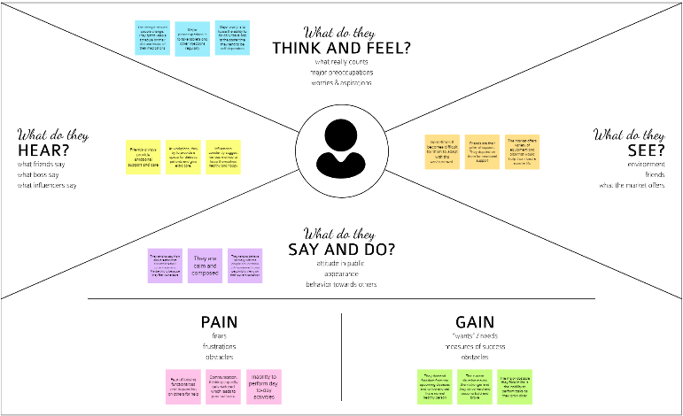

* 1. **IDEATION AND BRAINSTORMING**

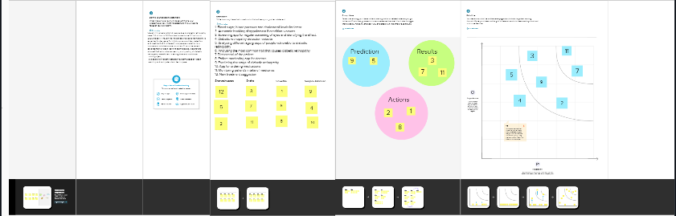

* 1. **PROPOSED SOLUTION**

|  |  |  |
| --- | --- | --- |
| **S. No.** | **Parameter** | **Description** |
| 1. | Problem Statement (Problem to be solved) | Diabetes is a globally prevalent disease that can cause visible microvascular complications such as diabetic retinopathy in the human eye retina, the images of which are today used for manual disease screening and diagnosis. This labour-intensive task could greatly benefit from automatic detection using deep learning technique |
| 2. | Idea / Solution description | Here we present a deep learning system that identifies referable diabetic retinopathy comparably or better than presented in the previous studies, although we use only a small fraction of images (less than 1/4th) in training but are aided with higher image resolutions. |
| 3. | Novelty / Uniqueness | We are providing novel results for five different screening and clinical grading systems for diabetic retinopathy including state of the art results for more accurately classifying images according to clinical five grade diabetic retinopathy |

|  |  |  |
| --- | --- | --- |
| 4. | Social Impact / Customer Satisfaction | This deep learning model can be used to identify people with diabetic retinopathy and Diagnose the clinical grade of diabetic retinopathy in them |
| 5. | Business Model (Revenue Model) |  |
| 6. | Scalability of the Solution | This deep learning system could increase the cost effectiveness of screening and diagnosis attaining higher than recommended performance and that the system could be applied in clinical examinations requiring finer grading |

* 1. 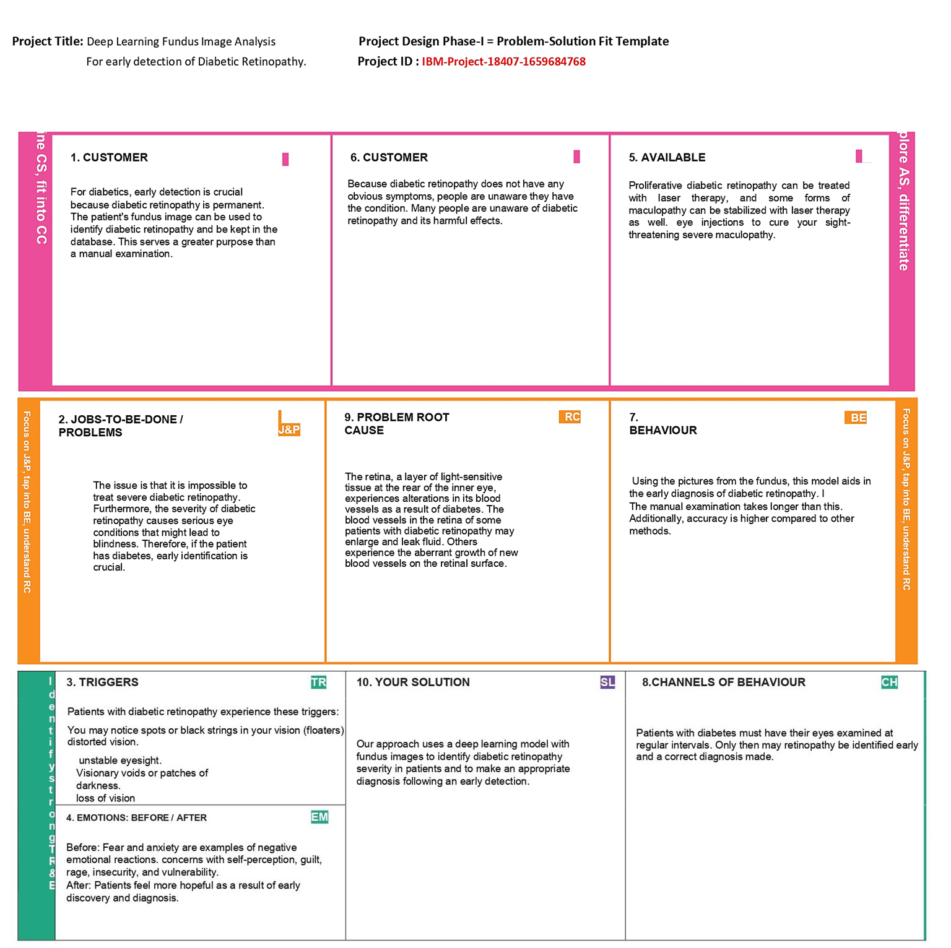**PROPOSED SOLUTION FIT**

1. **REQUIREMENT ANALYSIS**

## 4.1. Functional Requirements

Following are the functional requirements of the proposed solution.

|  |  |  |
| --- | --- | --- |
| **FR No.** | **Functional Requirement (Epic)** | **Sub Requirement (Story/ Sub-Task)** |
| FR-1 | User Registration | Registration through Form Registration through Gmail |
| FR-2 | User Confirmation | Confirmation via Email |
| FR-3 | User Information | Enter user details. The image of the user must be  uploaded |
| FR-4 | User input | Upload the user’s retinal scan |
| FR-5 | Result | Output is displayed in text area and option to download the report in .pdf format is available |

## 4.2. Non-functional Requirements:

Following are the non-functional requirements of the proposed solution.

|  |  |  |
| --- | --- | --- |
| **FR No.** | **Non-Functional Requirement** | **Description** |
| NFR-1 | **Usability** | This environment is user friendly,easily accessible and intuitive for people of |
| NFR-2 | **Security** | The user’s details and reports are stored and maintained securely for later retrieval |
| NFR-3 | **Reliability** | Even if the system fails the downtime is super low so the system recovers quickly |
| NFR-4 | **Performance** | The processing time of the web application (I.e time taken to enter the details and fetch results) is low |

|  |  |  |
| --- | --- | --- |
| NFR-5 | **Availability** | It is available around the clock 24x7 |
| NFR-6 | **Scalability** | The app should be capable of being expanded to a larger user base and still function the way it is intended to be |

1. **PROJECT DESIGN**
   1. **DATA FLOW DIAGRAM**

##### 

* 1. **TECHNOLOGY ARCHITECTURE**

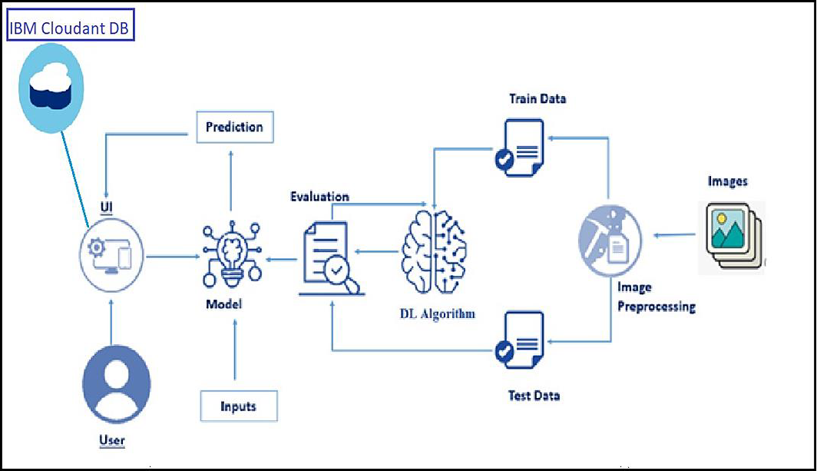

**Table-1: Components& Technologies**

|  |  |  |  |
| --- | --- | --- | --- |
| 1. | User Interface | Web UI | HTML, CSS, JavaScript, Python |
| 2. | Application logic-1 | Image Preprocessing | Keras,Tensorflow,Numpy |
| 3. | Application logic-2 | CNN Model | Keras,Tensorflow,Numpy |

|  |  |  |  |
| --- | --- | --- | --- |
| 4. | Application logic-3 | Web UI Application | Flask |
| 5. | Database | DR Images (Jpeg,Png,Jpg,Etc.,) | Uploads Folder |
| 6. | File storage | File Storage Requirements (Only If Necessary) | IBM Block Storage, GoogleDrive |
| 7. | External Api | Keras | Image Processing API |
| 8. | Deep Learning Model | Inception V3 Architecture | Pre-Trained Convolution NeuralNetwork Model |
| 9. | Infrastructure (Server) | Application Deployment on Webserver | Flask-A PythonWSGI HTTP Server. |

**Table-2: Application characteristics**

|  |  |  |  |
| --- | --- | --- | --- |
| **S.No** | **Characteristics** | **Description** | **Technology** |
| 1. | Open-Source Frameworks | Flask | Flask Frameworks |
| 2. | Security Implementations | CSRF Protection,Secure Flag For Cookies | Flask-WTF,  Session Cookie Secure |
| 3. | Scalable Architecture | Micro-Services | Micro Web Application FrameworkBy Flask |

* 1. **USER STORIES**

|  |  |  |  |  |  |  |
| --- | --- | --- | --- | --- | --- | --- |
| **User Type** | **Functional Requirement (Epic)** | **User Story**  **Number** | **User Story / Task** | **Acceptance criteria** | **Priority** | **Release** |
| Patient (Webuser) | Registration | USN-1 | I can register as a user on the website with eitheran email address or a phone  number and password. | I can createmy account. | High | Sprint-3 |
|  | Login | USN-2 | With theprovided Login credentials, I canaccessthe website  as a user. | I can log in andaccess myaccount  . | High | Sprint-3 |
|  | Upload image | USN-3 | I can post my data as a userin formats likepdf and doc. | I can uploadmy data. | Medium | Sprint-3 |
| Administratio n (Web developer) | Admin Login | USN-4 | I can log in to the website as theadmin and analyze the user information  . | I can log in and analyze the user data. | High | Sprint-3 |
|  | Data collection | USN-5 | I can gatherthe dataset forthe DR fromthe source as anadmin. | I can collect the dataset. | Low | Sprint-1 |
|  | Create model | USN-6 | I can buildthe model andtrain it using  the dataset as an  administrator to makepredictions. | I can create andtrain the model. | High | Sprint-1 |
|  | Test the model | USN-7 | I canevaluate the model's predictive  abilities as an admin. | I can testthe model. | High | Sprint-2 |
| Patient (Web user) | Diagnosis | USN-8 | I can access the application's diagnosisresults as a userand continue with  treatments.. | He/she can get the resultsand continue the treatment. | High | Sprint-2 |

1. **PROJECT PLANNING AND SCHEDULING**
   1. **SPRINT PLANNING AND ESTIMATION**

|  |  |  |  |  |  |  |
| --- | --- | --- | --- | --- | --- | --- |
| **Sprint** | **Functional**  **Requirement (Epic)** | **User Story**  **Number** | **User Story / Task** | **Story Points** | **Priority** | **Team**  **Members** |
| Sprint-1 | Working with Dataset | USN-1 | To download and import the dataset along with necessary libraries | 5 | High | Sharveshwaran R |
| USN-2 | To analyze the data and handle missing data | 5 | High | Sanjeev Krishnan R |
| USN-3 | To perform data visualization and find dependent and independent features | 5 | Low | Sneha K S |
| USN-4 | To perform feature scaling and split dataset into train and test | 5 | Medium | Shwetha M |
| Sprint-2 | Model Decision | USN-5 | To train and test CNN model and find the accuracy | 10 | Medium | Sharveshwaran R  Shwetha M |
| USN-6 | To predict the results using CNN model | 10 | Medium | Sanjeev Krishnan R  Sneha K S |
| Sprint-3 | Building web application | USN-7 | Creating a web page for content display | 10 | High | Shwetha M  Sneha K S |
| USN-8 | Creating python script for prediction and rendering to web page | 10 | High | Sharveshwaran R  Sanjeev Krishnan R |

|  |  |  |  |  |  |  |
| --- | --- | --- | --- | --- | --- | --- |
| Sprint-4 | Export Application | USN-9 | Run and export the application | 20 | High | Sharveshwaran R  Shwetha M  Sanjeev Krishnan R  Sneha K S |

|  |  |  |  |  |  |  |
| --- | --- | --- | --- | --- | --- | --- |
| **Sprint** | **Total story point** | **Duration** | **Sprint Start Date** | **Sprint End Date (Planned)** | **Story Points Completed (as**  **on Planned End Date)** | **Sprint Release Date(Actual)** |
| Sprint-  1 | 20 | 6 Days | 24 Oct  2022 | 29 Oct 2022 | 20 | 29 Oct 2022 |
| Sprint-  2 | 20 | 6 Days | 31 Oct  2022 | 05 Nov 2022 | 20 | 05 Nov 2022 |
| Sprint-  3 | 20 | 6 Days | 07 Nov  2022 | 12 Nov 2022 | 20 | 12 Nov 2022 |
| Sprint-  4 | 20 | 6 Days | 14 Nov  2022 | 19 Nov 2022 | 20 | 19 Nov 2022 |

## Velocity:

Imagine we have a 10-daysprint duration, and the velocity of the team is 20 (points per sprint). Let’s calculate the team’s average velocity (AV) periteration unit (story points per day).

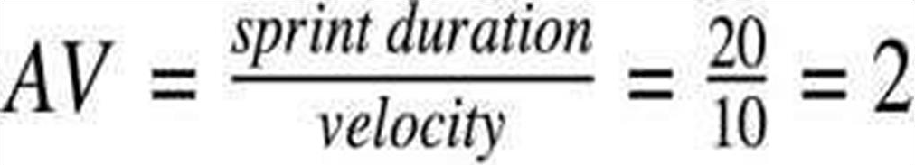

AV=20/6=3.33points per day.

## Burn Down Chart & JIRA :

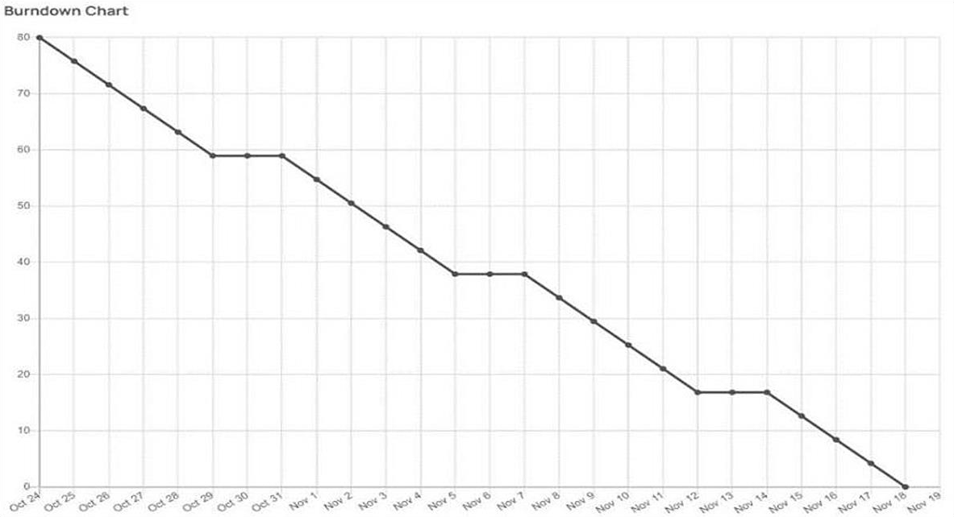

A burn down chart plots the amount of work remaining to perform against the amount of time. In agilesoftware development approaches like Scrum, it is frequently employed. Burn down charts, however,can beused for any project that makes observable progress over time.

1. **CODING AND SOLUTION:-**

**Feature 1:-**

We have devloped a website which authenticates users and help them upload and check the seriousness of the diabetics.

**Feature 2:-**

We have devloped a multilayer deep convolutional nueral network that classifies the user image of a eye to which extense has the disease diabetics has been affected.The model will classify the images into 5 categories of diabetics and report them on asking for prediction. We have also devloped a messaging service for recieiving message for the type of diabetics.

1. **TESTING:-**
   1. **TEST CASES:-**
   2. **USER ACCEPTANCE TESTING:-**

### Purpose of Document:-

This document serves as a quick reference for the Deep Learning Fundus Image Analysis for Early Detection of Diabetic Retinopathy project's test coverage and open issues as

of the project's release for user acceptance testing.

### Defect Analysis:-

This shows how many bugs were fixed or closed at each severity level and how they were fixed.

|  |  |  |  |  |  |
| --- | --- | --- | --- | --- | --- |
| **Resolution** | **Severity 1** | **Severity 2** | **Severity 3** | **Severity4** | **Subtotal** |
| By Design | 5 | 4 | 2 | 3 | 14 |
| Duplicate | 1 | 0 | 3 | 0 | 4 |
| External | 2 | 3 | 0 | 1 | 6 |
| Fixed | 9 | 2 | 4 | 15 | 30 |

|  |  |  |  |  |  |
| --- | --- | --- | --- | --- | --- |
| Not Reproduced | 0 | 0 | 1 | 0 | 1 |
| Skipped | 0 | 0 | 1 | 1 | 2 |
| Won'tFix | 0 | 5 | 2 | 1 | 8 |
| Totals | 17 | 14 | 13 | 21 | 65 |

### Test-CaseAnalysis

This report shows the number of test cases that have passed, failed,and untested.

|  |  |  |  |  |
| --- | --- | --- | --- | --- |
| **Section** | **TotalCases** | **Not Tested** | **Fail** | **Pass** |
| PrintEngine | 9 | 0 | 0 | 9 |
| ClientApplication | 45 | 0 | 0 | 45 |
| Security | 2 | 0 | 0 | 2 |
| Out-sourceShipping | 3 | 0 | 0 | 3 |
| ExceptionReporting | 9 | 0 | 0 | 9 |
| FinalReportOutput | 4 | 0 | 0 | 4 |
| VersionControl | 2 | 0 | 0 | 2 |



1. **RESULTS:-**

## Performance Metrics:- Model Performance Testing:

|  |  |  |  |  |
| --- | --- | --- | --- | --- |
| **S. NO** | **Parameter** | **Values** | **Screenshot** |  |
| 1. | Model Summary | **Total params: 21,885,485**  **Trainable params: 1,024,005 Non-trainable params: 20,861,480** |  |
| 2. | Accuracy | Training Accuracy – **0.7917**  Validation Accuracy – **loss 3.2610** |  |
| 3. | Confidence Score(Only Yolo Projects) | Class Detected - Confidence  Score - | --  --  --  -- |

Project team shall fill the following information in model performance testing template.

1. **ADVANTAGES AND DISADVANTAGES**
   1. **ADVANTAGES**

There are several advantages of using deep learning for fundus image analysis for early detection of diabetic retinopathy.

First, deep learning is well-suited for image analysis tasks. This is because deep learning algorithms can automatically learn features from images, which is essential for accurate image analysis.

Second, deep learning is efficient at handling large amounts of data. This is important for medical image analysis, as medical images are often very large.

Third, deep learning is scalable. This means that it can be used to train models on very large datasets, which is important for medical image analysis tasks where data is often limited.

Fourth, deep learning is able to learn from data with little supervision. This is important for medical image analysis, as often there is limited labeled data available.

Finally, deep learning is robust. This means that it is less likely to overfit to the data, which is important for medical image analysis where data is often limited.

* 1. **DISADVANTAGES**

There are several disadvantages of deep learning for early detection of diabetic retinopathy. One disadvantage is that deep learning requires a large amount of data to train the models. This can be a challenge for researchers who do not have access to a large dataset. Another challenge is that deep learning models can be very complex, which can make them difficult to interpret. Finally, deep learning models can be computationally intensive, which can make them difficult to deploy in resource-limited settings.

1. **CONCLUSION**

Diabetic retinopathy (DR) is a leading cause of blindness in the United States. Early detection and treatment of DR is critical to preventing vision loss. However, DR is often asymptomatic in its early stages, making it difficult to detect. Deep learning (DL) is a type of artificial intelligence that can be used to automatically detect patterns in data. DL has been shown to be effective for detecting DR in images of the retina. In this study, a DL algorithm was used to automatically detect DR in fundus images. The algorithm was able to accurately detect DR in early stages, before it is symptomatic. This could potentially lead to earlier diagnosis and treatment of DR, which could help to prevent vision loss.

1. **FUTURE SCOPE**

There is a great potential for deep learning in fundus image analysis for early detection of diabetic retinopathy. However, there are a few challenges that need to be addressed. First, the current data sets are small and lack diversity. Second, the images are often low quality and need to be pre-processed before they can be used for deep learning.

Third, the ground truth labels for the images are often not available. Finally, the current deep learning models are not able to generalize well to real-world data.

1. **APPENDIX**

#### app.py:-

import numpy as np import os

from tensorflow.keras.models import load_model from tensorflow.keras.preprocessing import image

from tensorflow.keras.applications.inception_v3 import preprocess_input from flask import Flask, request,flash, render_template, redirect,url_for from cloudant.client import Cloudant

from twilio.rest import Client

model = load_model(r"Updated-xception-diabetic-retinopathy.h5") app = Flask( name )

app.secret_key="abc" app.config['UPLOAD_FOLDER'] = "User_Images" # Authenticate using an IAM API key

client = Cloudant.iam('c2122ee4-b4d5-4cd4-a15a-26af8dc9533e-bluemix', '1HTTyEGgmFvrcaEzQqHflsuHpqZ3Y4UUsChgqXcIW_Ze', connect=True)

# Create a database using an initialized client my_database = client.create_database('my_database') if my_database.exists():

print("Database '{0}' successfully created.".format('my_db')) # default home page or route

user = ""

@app.route('/') def index():

return render_template('index.html', pred="Login", vis ="visible")

@ app.route('/index') def home():

return render_template("index.html", pred="Login", vis ="visible")

# registration page

@ app.route('/register',methods=["GET","POST"])

def register():

if request.method == "POST":

name = request.form.get("name") mail = request.form.get("emailid") mobile = request.form.get("num") pswd = request.form.get("pass") data = {

'name': name,

'mail': mail, 'mobile': mobile, 'psw': pswd

}

print(data)

query = {'mail': {'$eq': data['mail']}}

docs = my_database.get_query_result(query) print(docs)

print(len(docs.all()))

if (len(docs.all()) == 0):

url = my_database.create_document(data)

return render_template("register.html", pred=" Registration Successful , please login using your details ") else:

return render_template('register.html', pred=" You are already a member , please login using your details ")

else:

return render_template('register.html')

@ app.route('/login', methods=['GET','POST']) def login():

if request.method == "GET": user = request.args.get('mail') passw = request.args.get('pass') print(user, passw)

query = {'mail': {'$eq': user}}

docs = my_database.get_query_result(query) print(docs)

print(len(docs.all()))

if (len(docs.all()) == 0):

return render_template('login.html', pred="") else:

if ((user == docs[0][0]['mail'] and passw == docs[0][0]['psw'])): flash("Logged in as " + str(user))

return render_template('index.html', pred="Logged in as "+str(user), vis ="hidden", vis2="visible") else:

return render_template('login.html', pred="The password is wrong.")

else:

return render_template('login.html')

@ app.route('/logout') def logout():

return render_template('logout.html')

@app.route("/predict",methods=["GET", "POST"]) def predict():

if request.method == "POST": f = request.files['file']

# getting the current path 1.e where app.py is present basepath = os.path.dirname( file )

#print ( " current path " , basepath )

# from anywhere in the system we can give image but we want that filepath = os.path.join(str(basepath), 'User_Images', str(f.filename)) #print ( " upload folder is " , filepath )

f.save(filepath)

img = image.load_img(filepath, target_size=(299, 299)) x = image.img_to_array(img) # ing to array

x = np.expand_dims(x, axis=0) # used for adding one more dimension #print ( x )

img_data = preprocess_input(x)

prediction = np.argmax(model.predict(img_data), axis=1) index = [' No Diabetic Retinopathy ', ' Mild NPDR ',

' Moderate NPDR ', ' Severe NPDR ', ' Proliferative DR '] result = str(index[prediction[0]])

print(result)

return render_template('prediction.html', prediction=result, fname = filepath) else:

return render_template("prediction.html")

if name == " main ": app.debug = True app.run()

<div class="mb-3 d-flex justify-content-center">

<a href="login" class="nav-link"> Already Registered: Login Here</a>

## Python Notebook screenshots:-

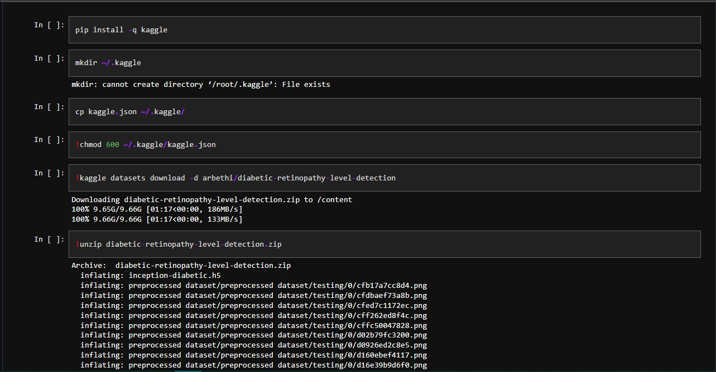

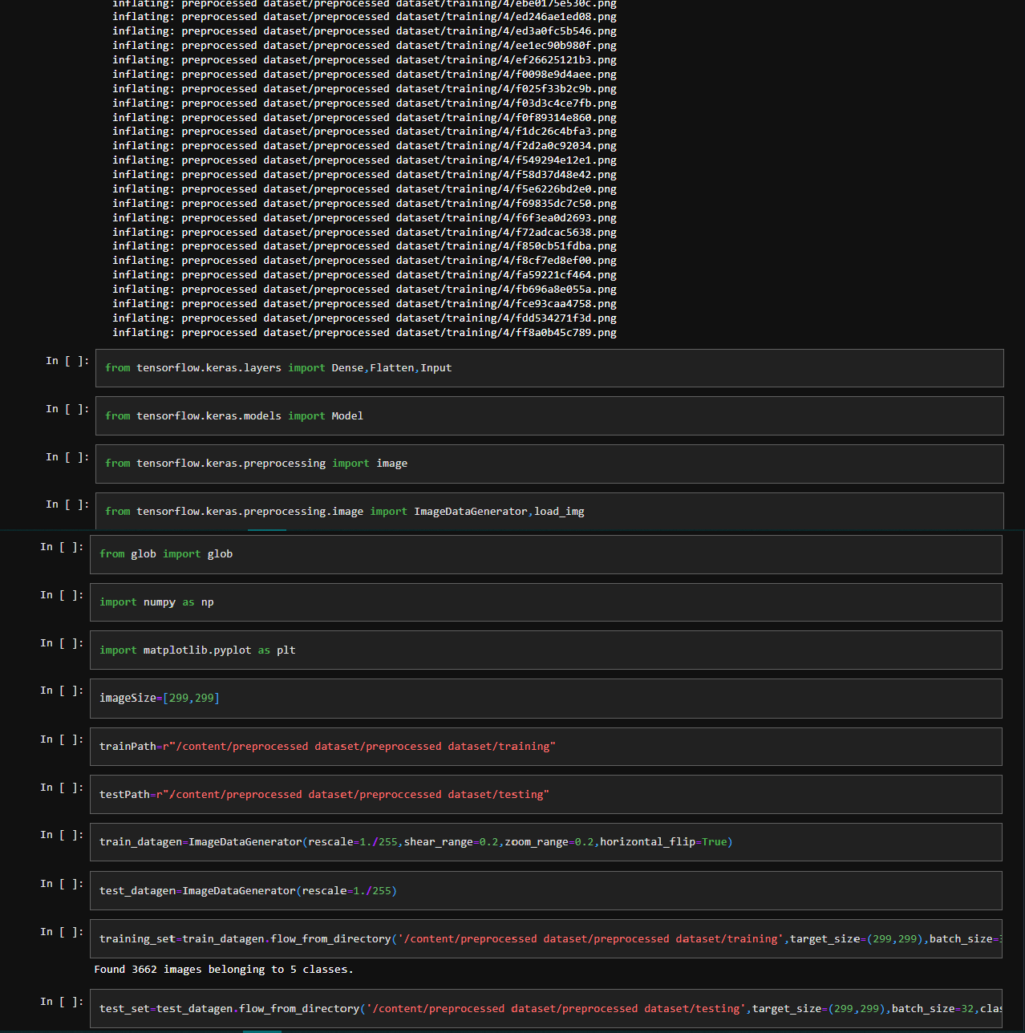

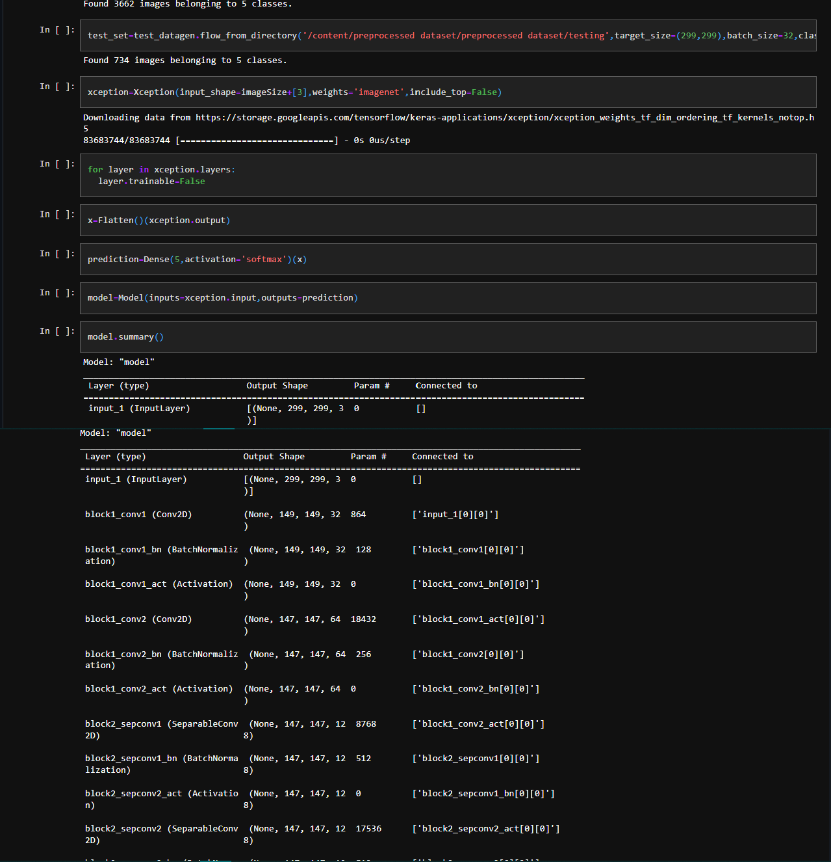

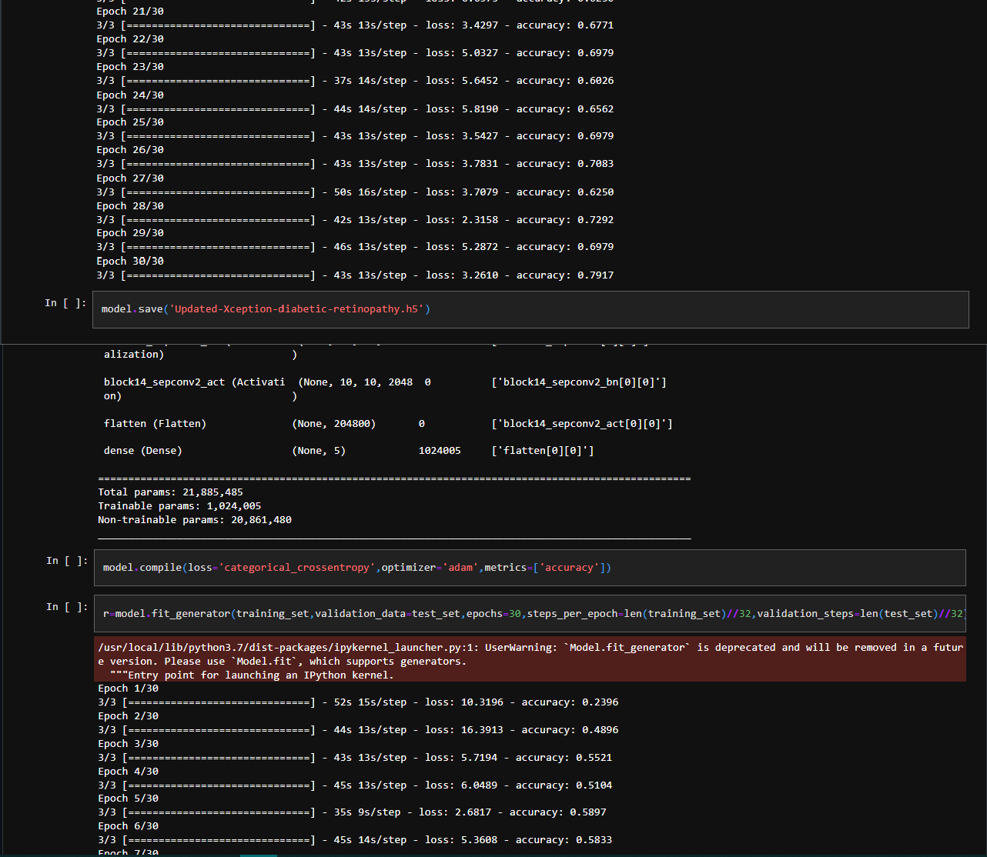

**GITHUB LINK:-** [**https://github.com/IBM-EPBL/IBM-Project-14061-1659539858**](https://github.com/IBM-EPBL/IBM-Project-14061-1659539858)

**DEMO LINK:-** [**https://github.com/IBM-EPBL/IBM-Project-14061-1659539858/tree/main/Final%20Deliverables/Demonstration%20Video**](https://github.com/IBM-EPBL/IBM-Project-14061-1659539858/tree/main/Final%20Deliverables/Demonstration%20Video)